Portfolio thingy

# Relevant files

<https://infocenter.nordicsemi.com/pdf/Thingy_UG_v1.1.pdf>

# Thingy blockdiagram

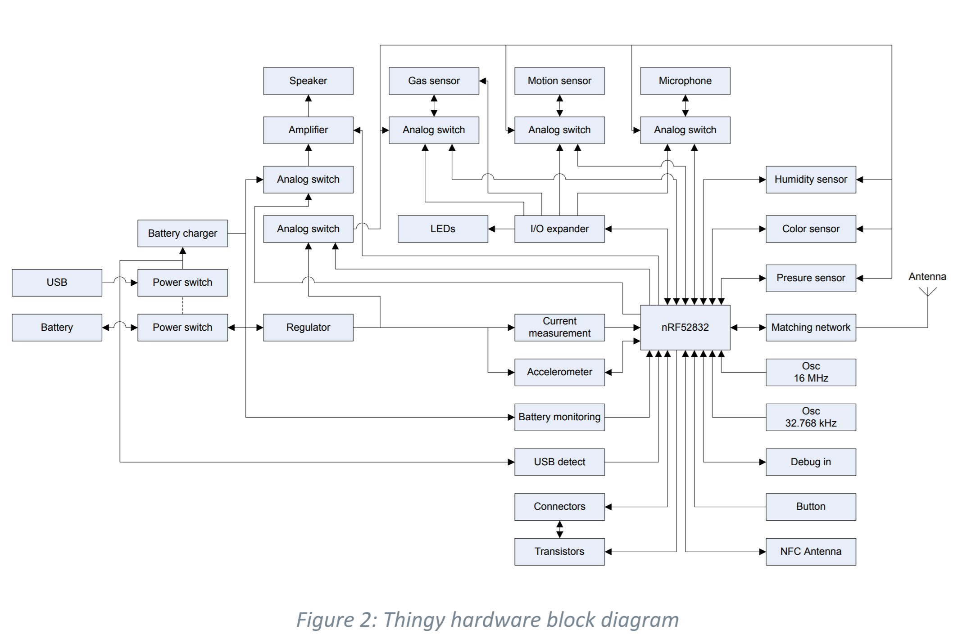

# Functionalities of the thingy

The thingy must do the following things:

* Check if distance is violated
* Make aware that somebody is sitting
* Consume minimal power as possible

# What I’ve done

**Turn off the unnecessary functionalities**

🡺 in main where it is initialized, we comment it out:

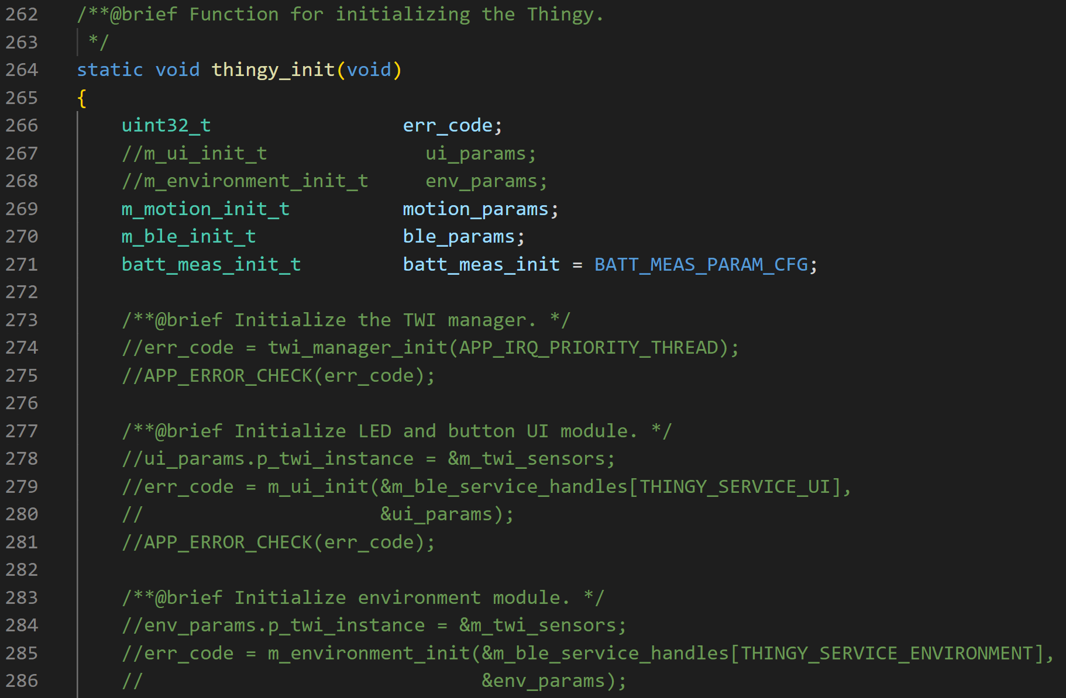

**Check is someone is sitting, else sleep**

To check if someone is sitting, we used a light sensor 🡺 if the p_data-> clear value is high, then no one is sitting on the chair. If it is low, then someone is sitting on the chair. This value should be tested somehow per classroom and see whats the best threshold value to decide when someone is sitting. At the moment, I’ve set it to 200 (but further research should be done to find the optimal value). If the value is higher, the thingy will go in sleep mode and the accelerometer will be prepared so that the thingy will wake up when the device is shaken. In the functions below (added in the “main.c” file) you can see what I just described in the code. Because the light sensor and the accelerometer are part of the internal I2C bus (because of the io expander) a configuration for the I2C settings are also necessary.

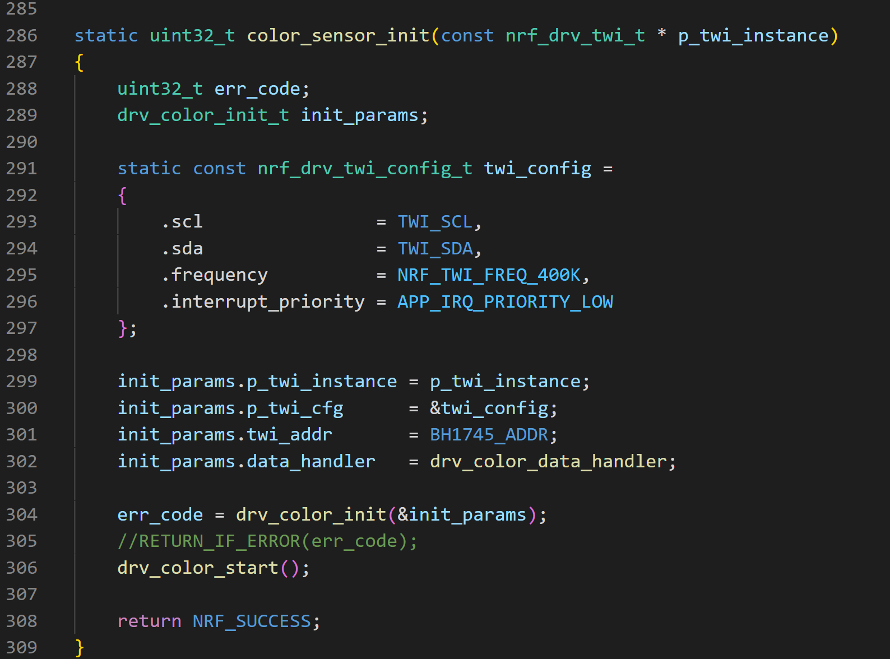

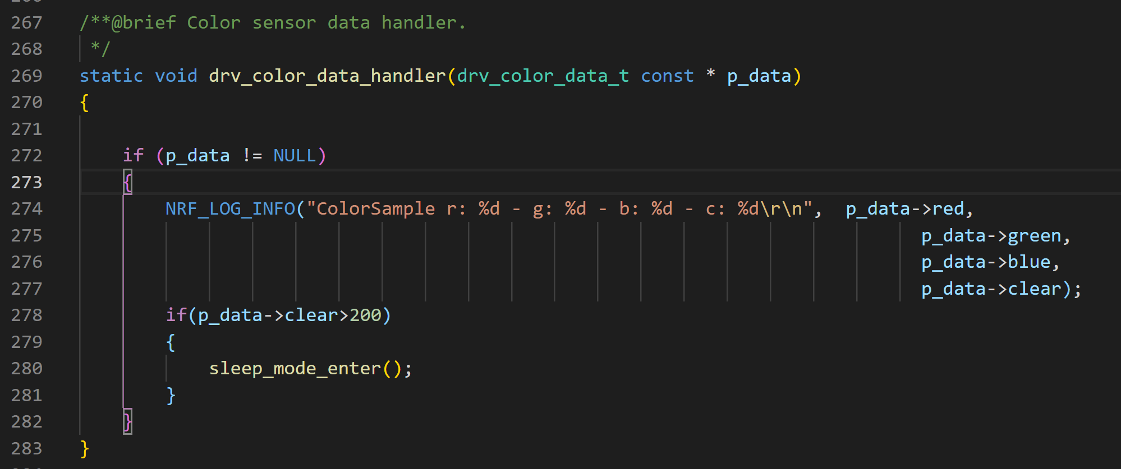

The sleep_mode_enter was already main.c file but the accelerometer needed to be initialized so it could work. The accelero_init() function can be found below (also in the “main.c” file).

We add “drv_color_sample” to the main loop. This function takes a sample of the light sensor and it gives an interrupt when it is done. This interrupt triggers the datahandler function.

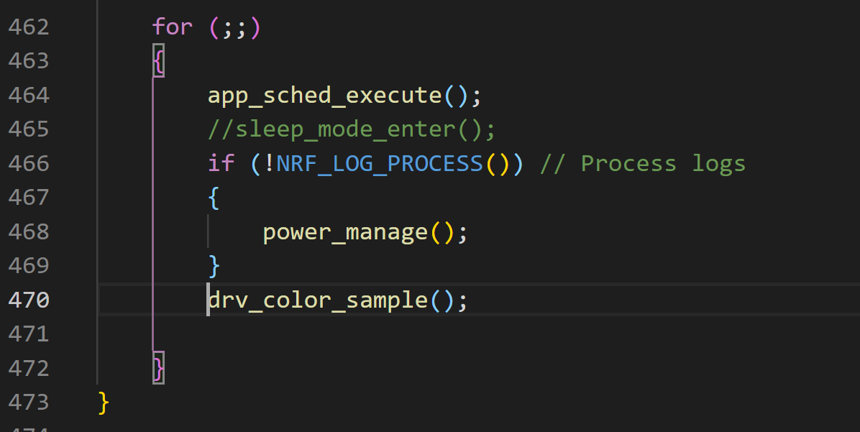

**Fixing the right BLE parameters and advertisement packet**

🡺

The advertisement interval and timout interval can be adjusted in the thingy_config.h file (as can many other parameters):

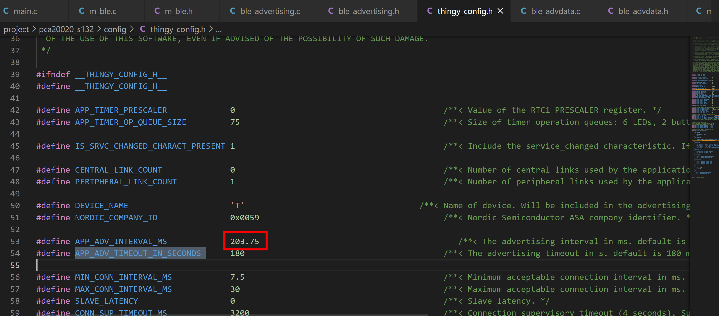

Advertisement knowledge 🡺 <https://devzone.nordicsemi.com/nordic/short-range-guides/b/bluetooth-low-energy/posts/bluetooth-smart-and-the-nordics-softdevices-part-1>

In the main loop, we use thingy_init where we initialize all the components that we need. One of the mis for the ble advertising and scanning.

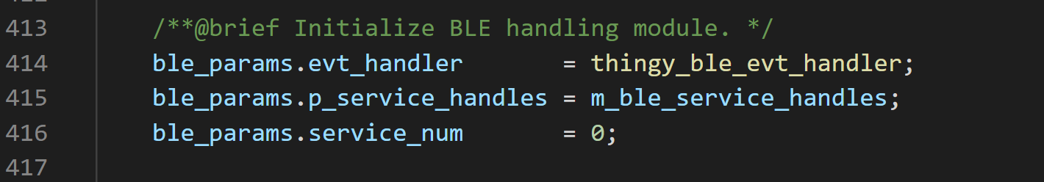

This ble handling module is defined in m_ble.c. This module initializes things like gap parameters, services, advertising,… Scanning was not initialized here but we will come to that later. Lets first take a look at how the **advertising** is initialized:

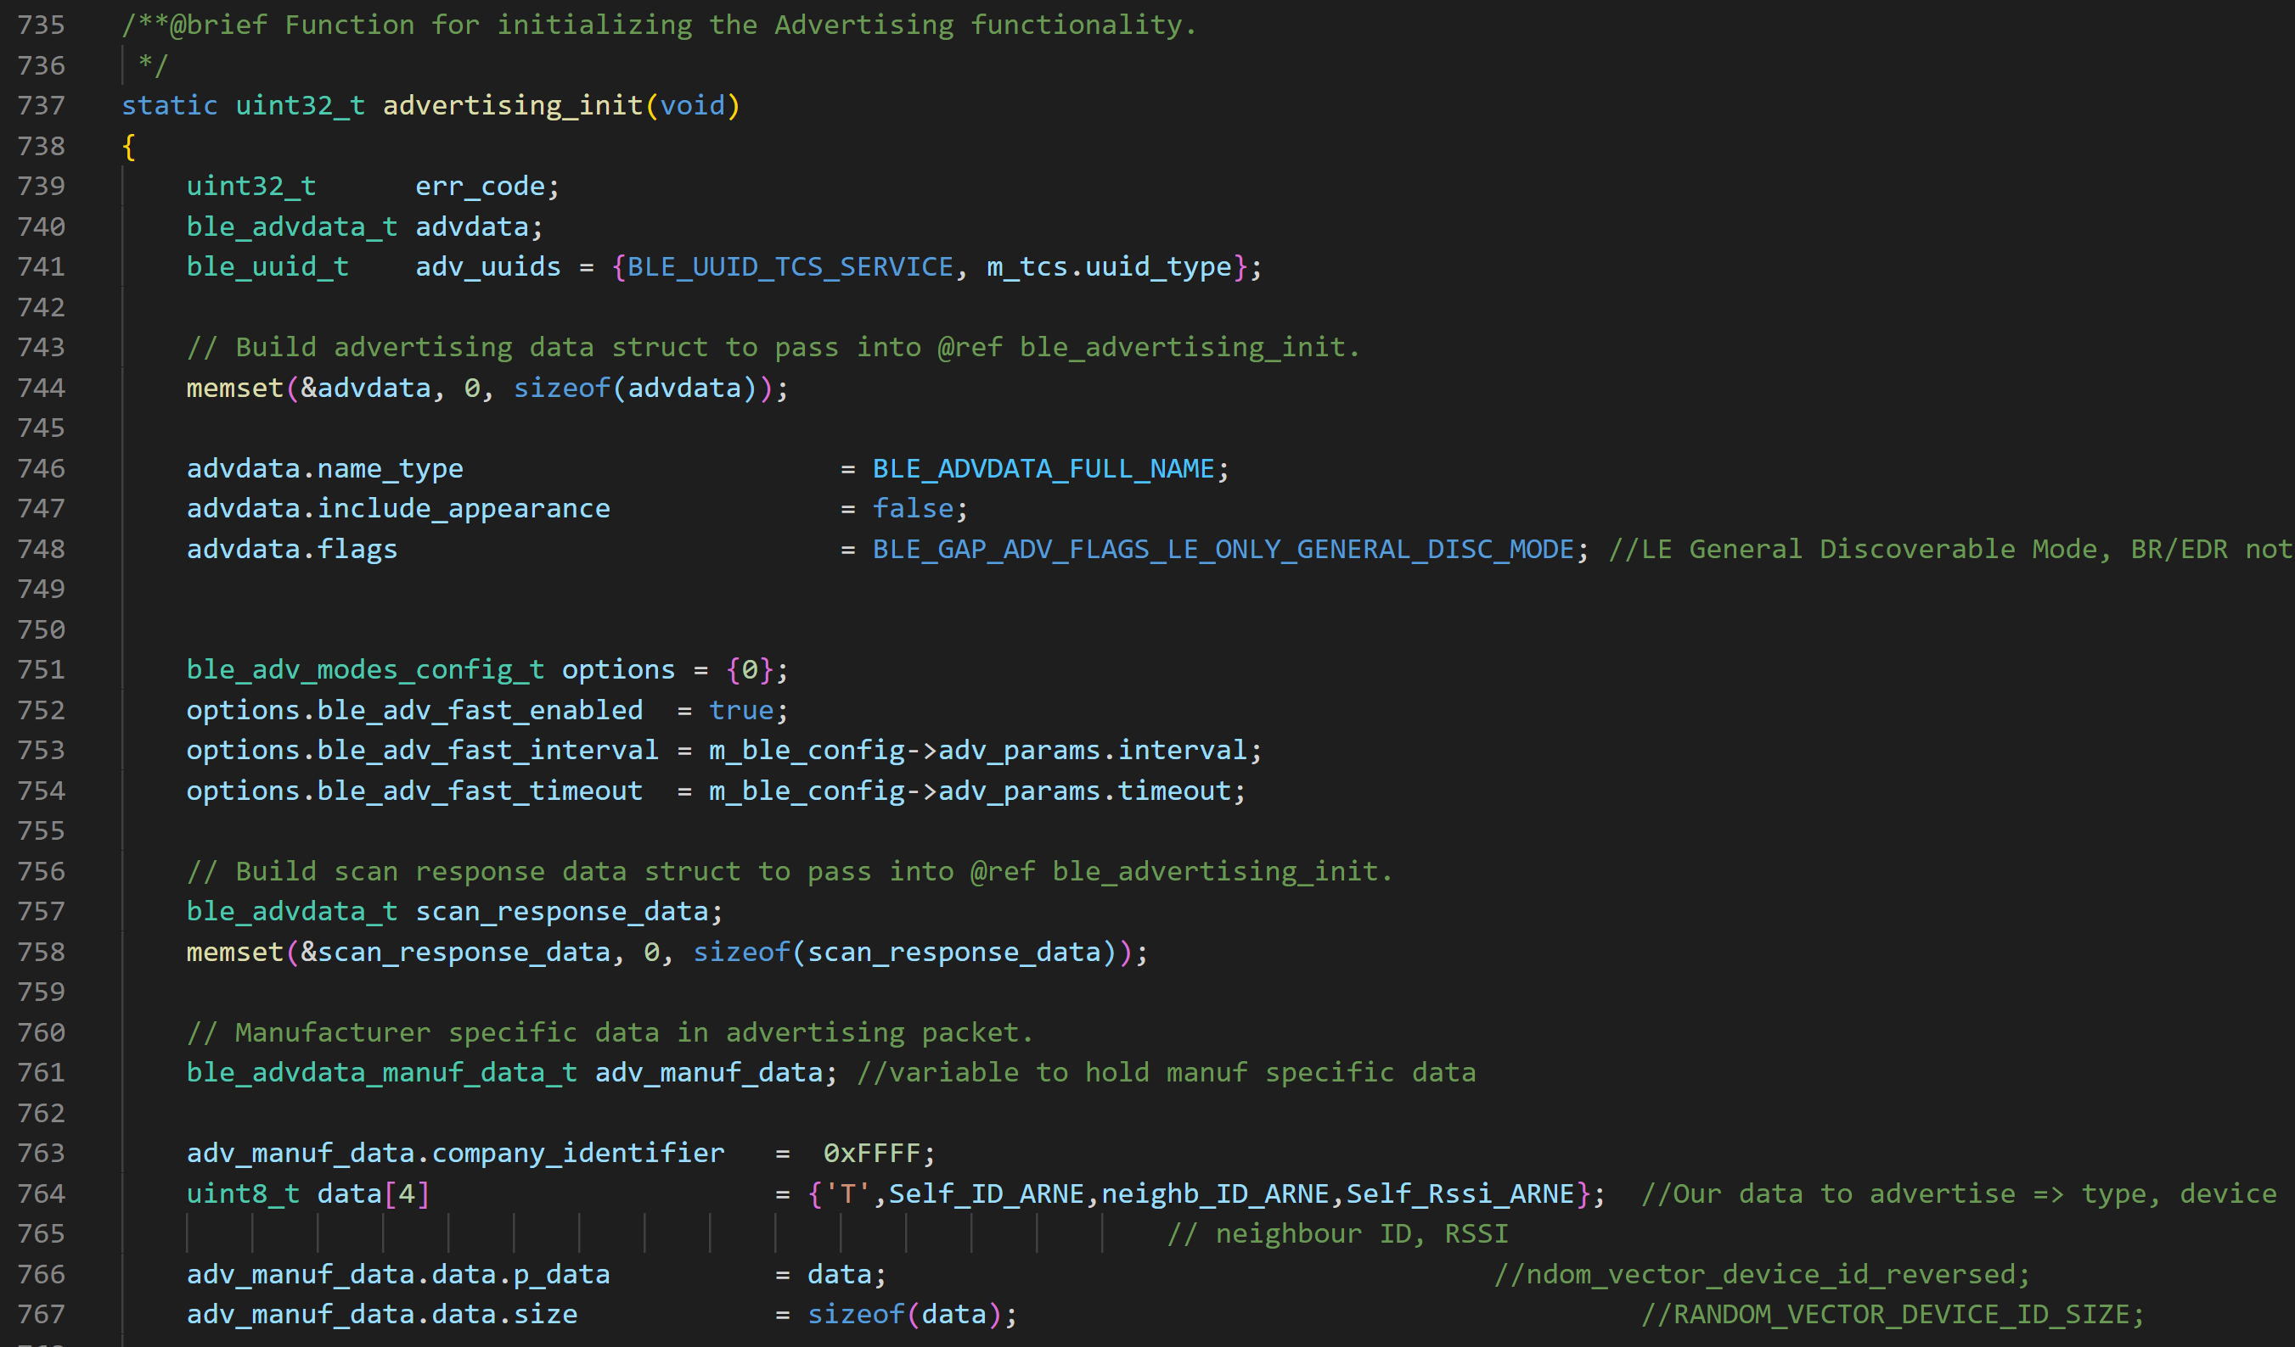

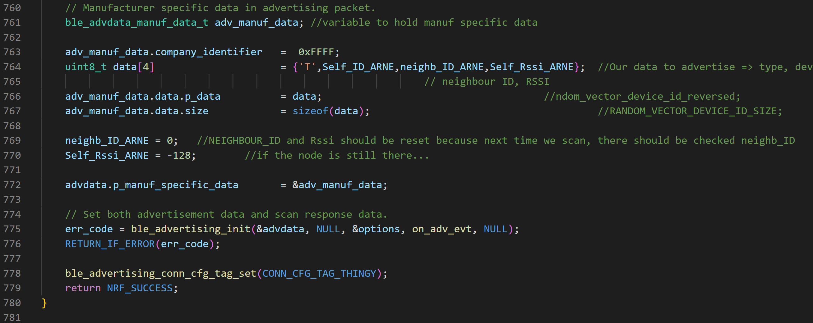

Here, all the parameters that are necessary are set correctly and for our own specific data, we use the manufacturing data field. Our raw data looks like this (first is the complete local name, then we have the flags => we couldn’t remove this. Then we have the manufacturing data which is: type(window or thingy sending) + ID (of the device that sent the data) + ID of neareast neighbour (defined by RSSI) + RSSI :

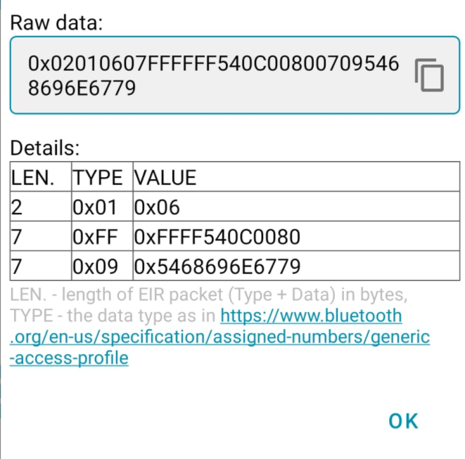

For the **scanner**, we define it in the main function:

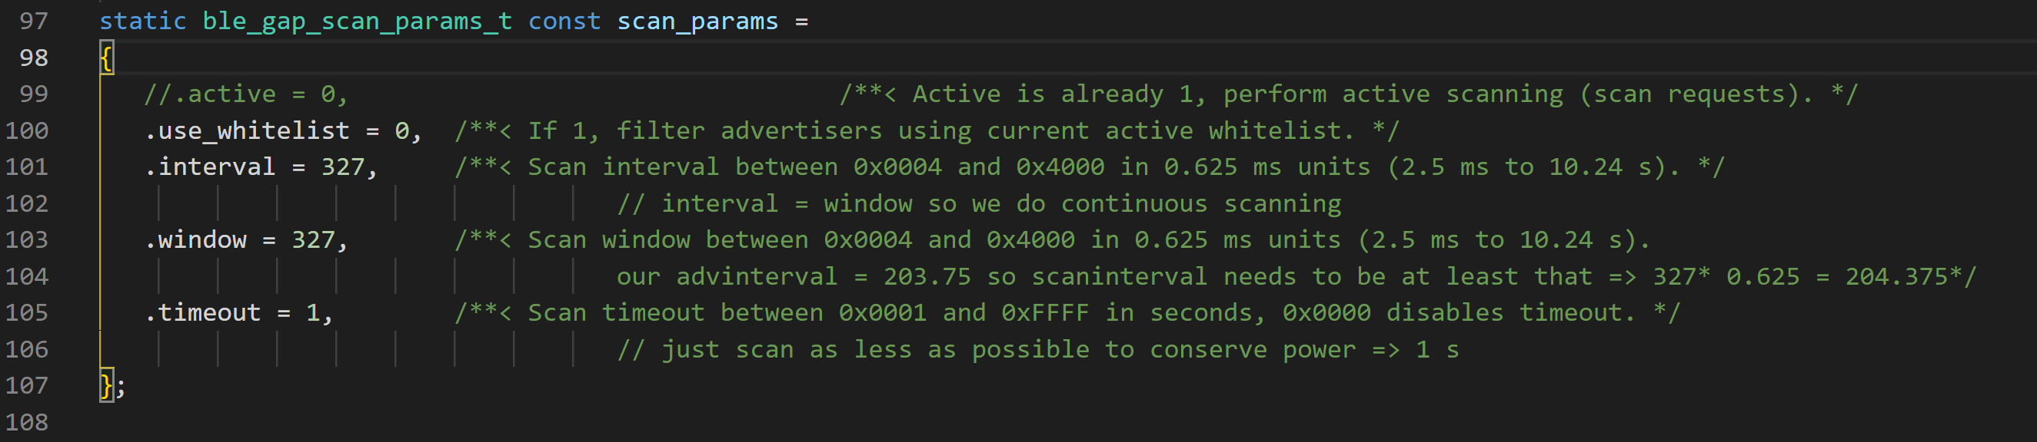

Notice the time out => this is for test purposes but it will be 1 eventually => 1 second scanning every thirthy seconds.   
We start the scanner in by calling the scanner_start() function:

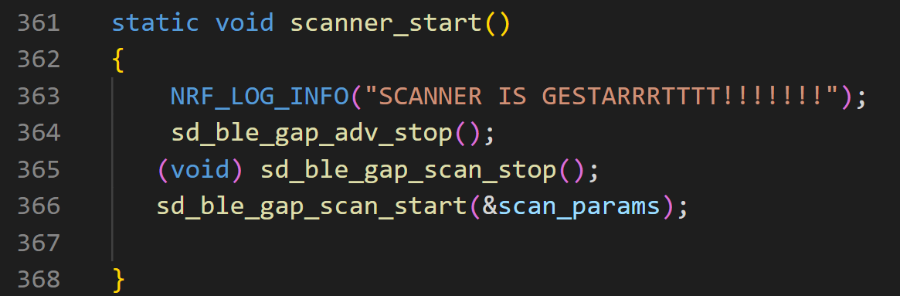

Notice we stop advertising (sd_ble_gap_adv_stop(). So we use the ble handler from the softdevice for this which is defined in m_ble.c. Here we add BLE_GAP_EVT_ADV_REPORT (the case when an advertisement is received) and BLE_GAP_EVT_TIMEOUT (here a ble timeout happens and we will check if the scanner timeouted but this if for later).

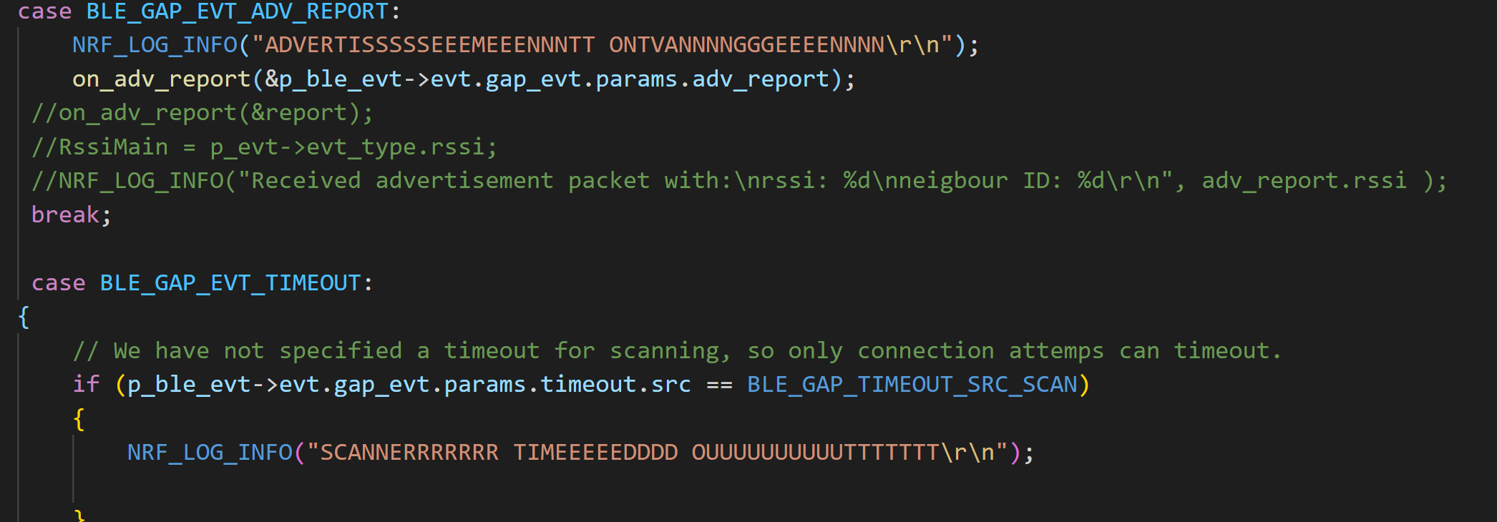

When an advertisement is received, there will be checked if it contains “Thingy” in the beginning of complete local name. If so, the rssi will be checked. If this is higher than before, the neighbour ID and RSSI in the advertisement packet will be updated.

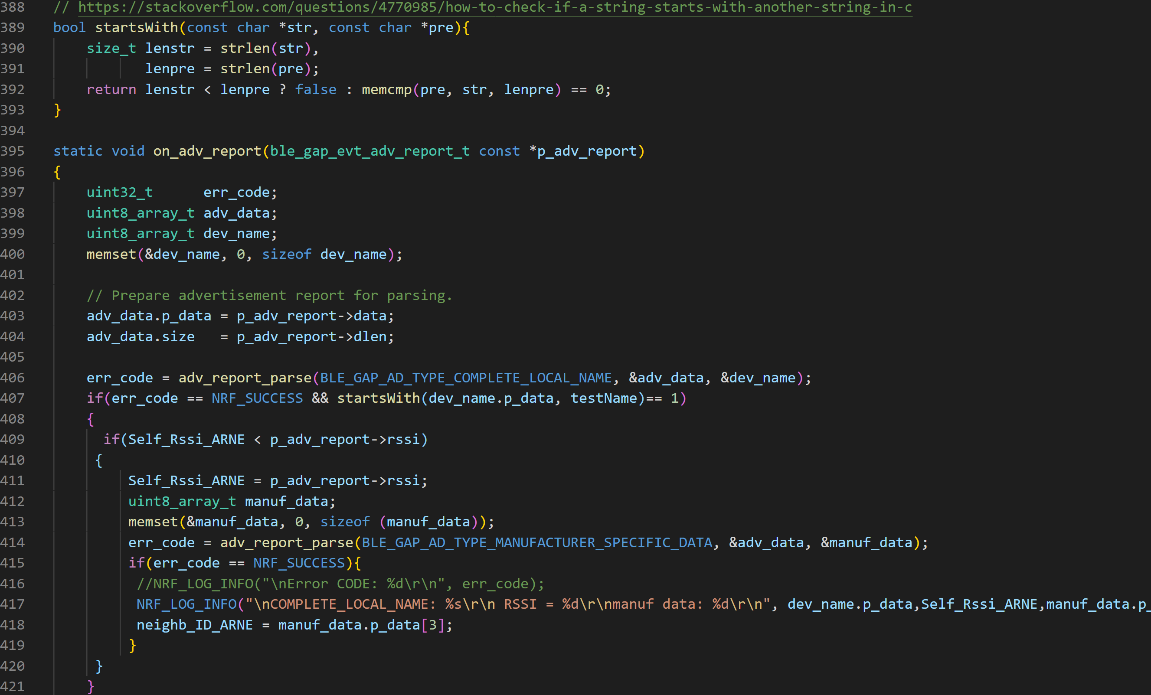

If the scanner times out (after 1 second in our project), the advertisement packet will updated with the new parameters:

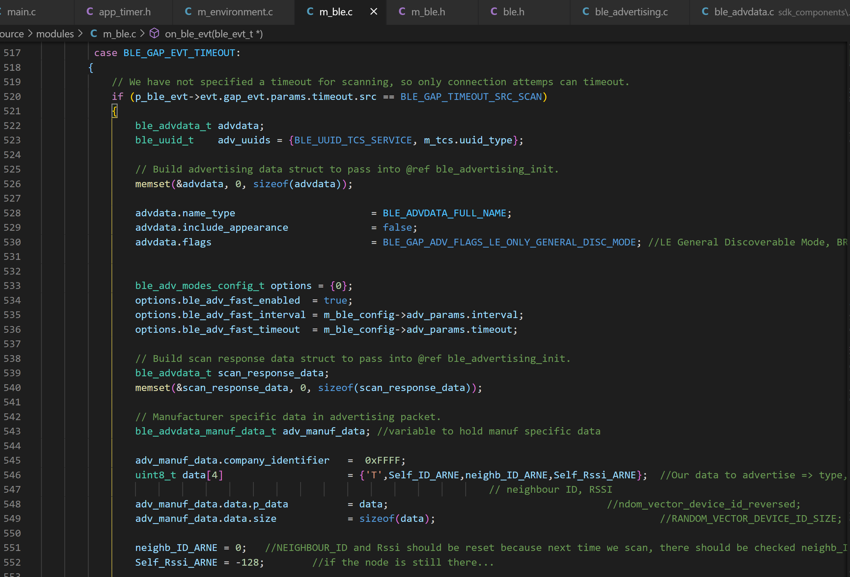

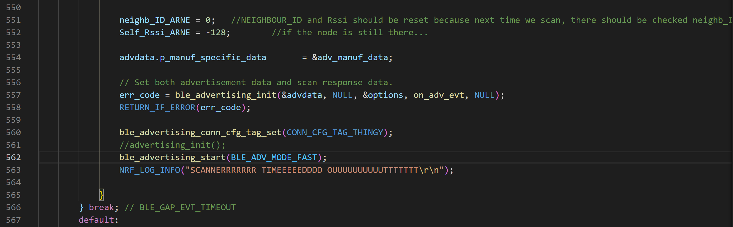

In main we define a timer so we will scan every … seconds:

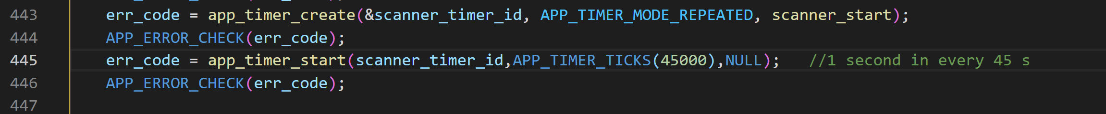

So in this case the scanner will be repeatedly triggerd (1 second in every 45 seconds).

In our test we can see the following:  
First when we advertise, we get the following packet:  
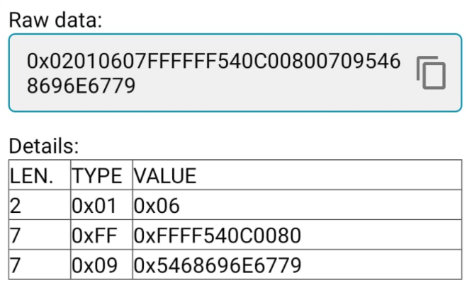

Second, when we first scan, we get an RSSI of -42 and later also -41:  
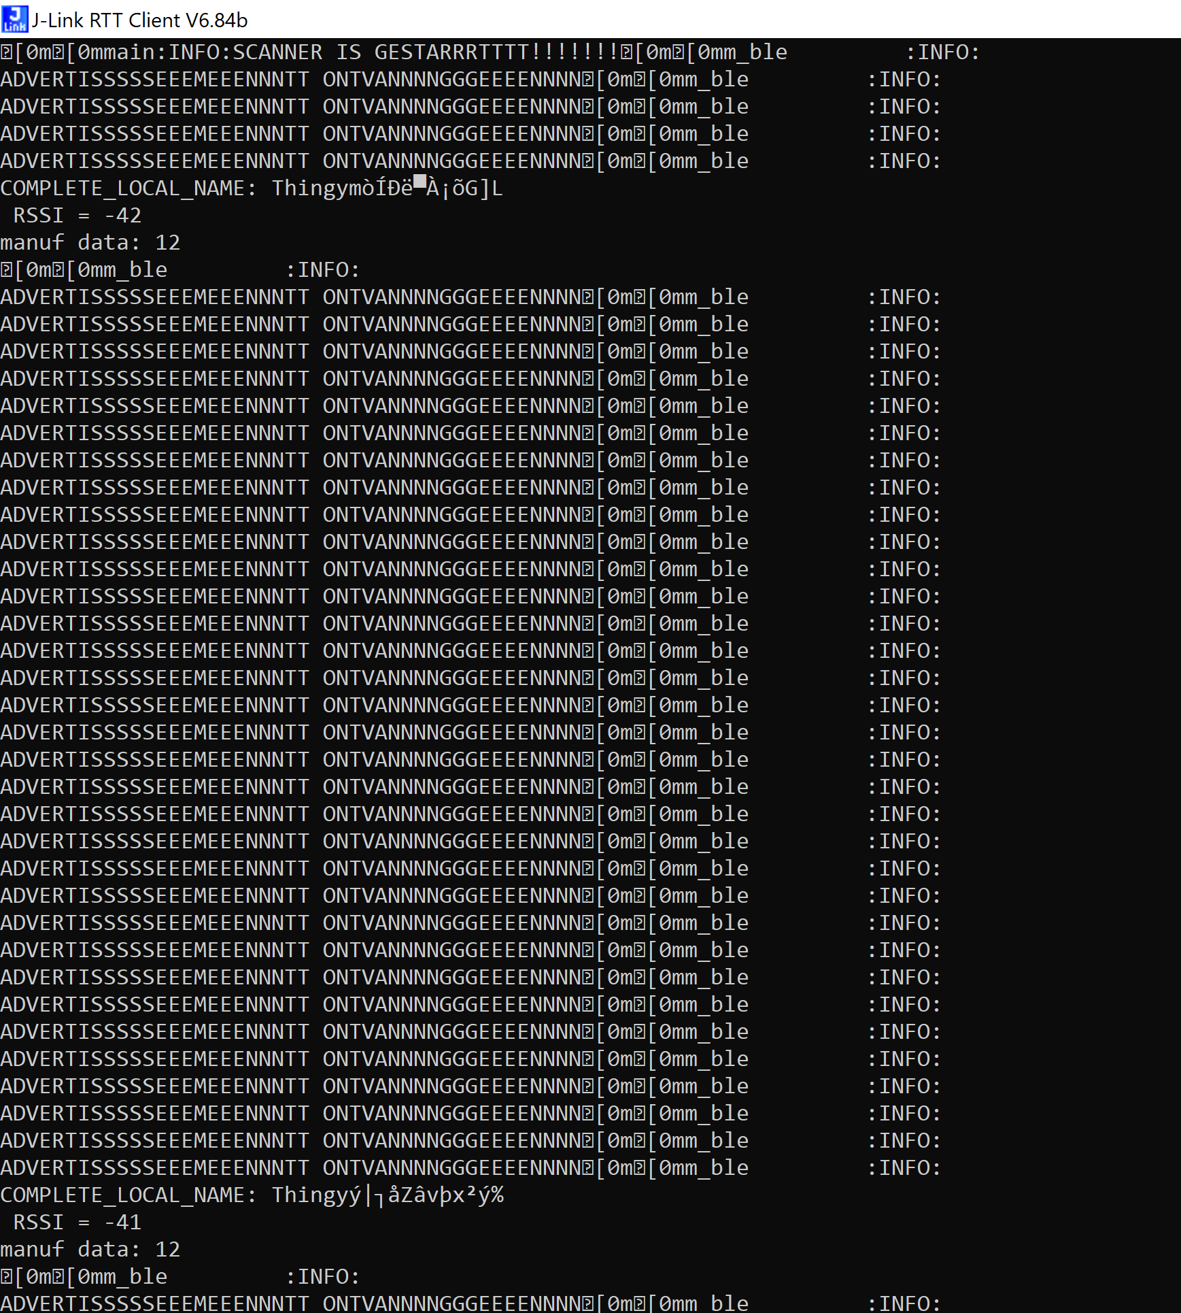

When we check the nrf_connect app again and we scan again, we see the advertisement packet is updated:

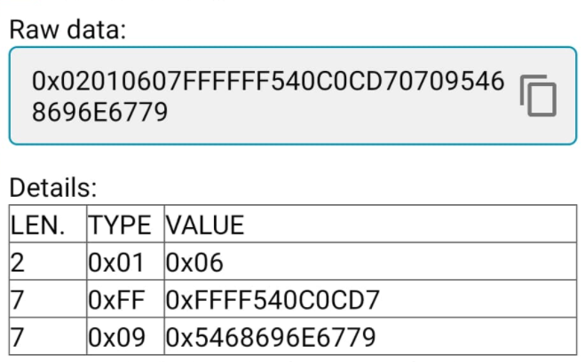

We can see the last four bytes of the manufacturer data are updated => 0C means that the neighbour has ID 12 and D7 means is the -41 RSSI.

When we turn off the other thingy (this means no other thingys in the neighbourhood of the scanning thingy and that it must use the default parameters again so neighb_Id = 00 and RSSI is 80 wich is -128 ):



After that we scan again and we see an RSSI of -47:  
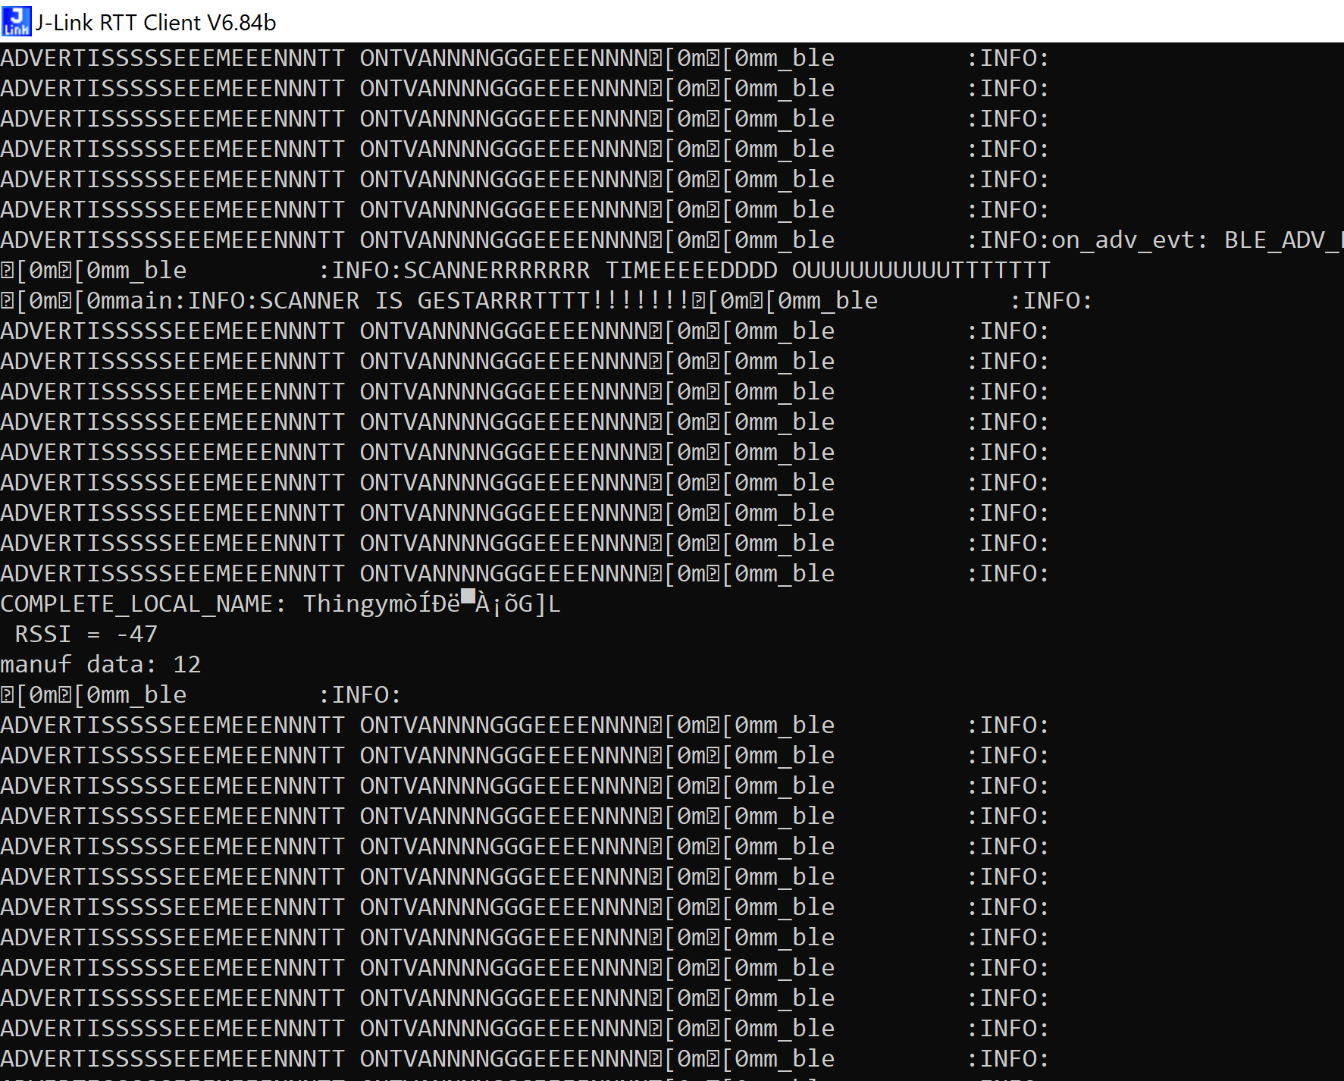

The packet is updated after the scanning and the advertising starts again so we see in the nrf app:  
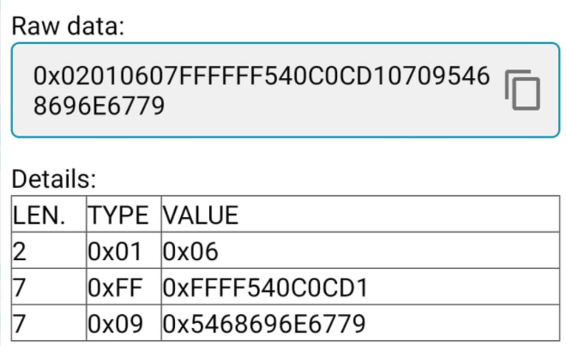

**Power management tests:**

First time measuring the thingy 🡺 nothing is implemented:

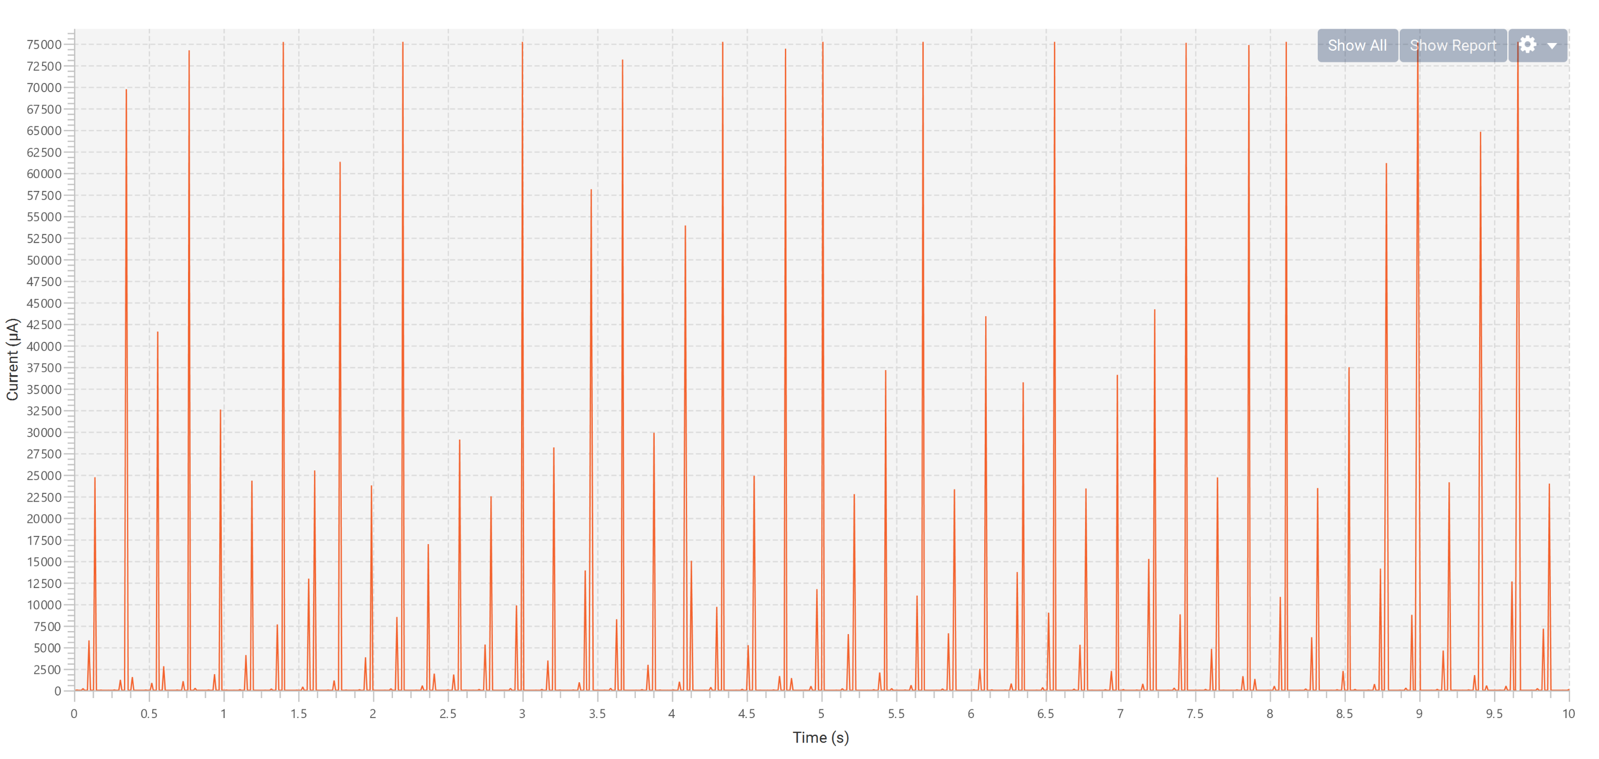

Sampling frequentie is te laag. Gebruik deze:

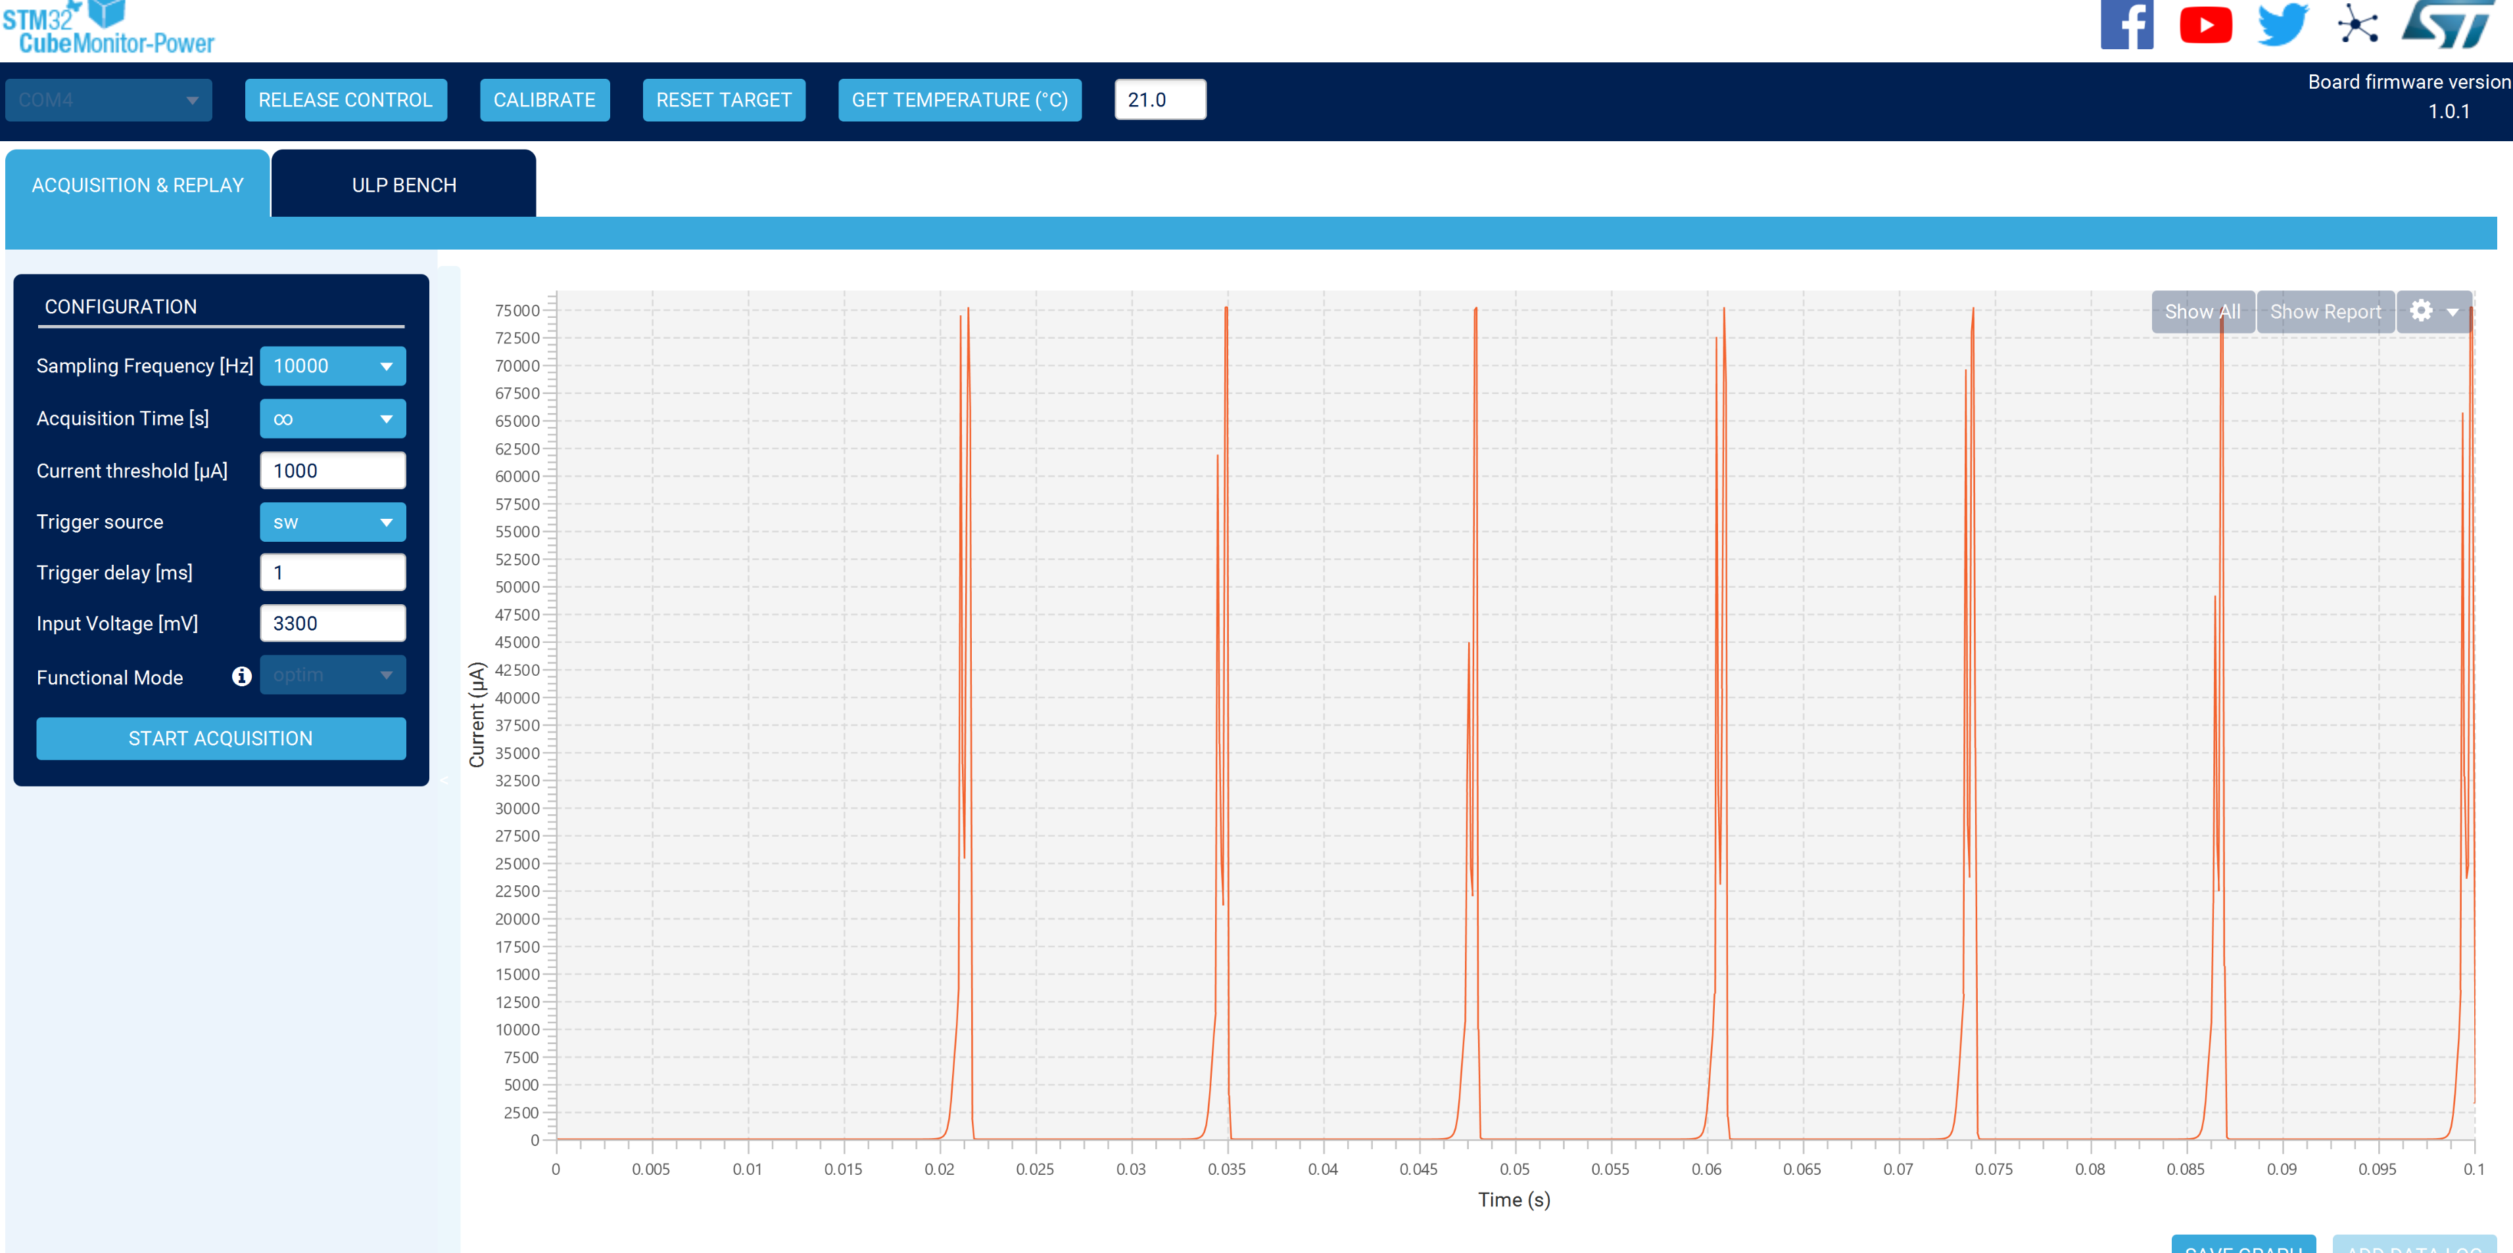

**Energy harvesting:**

We will use the BQ25570EVM module to convert the energy (from solar atm) to the thingy.  
This thing works as follows =>   
It gets a voltage from a source like solar panel. This powers a converter that converts the energy. When this reaches 1.8 volt, a better power converter will be used internal that more efficiently converts the voltage. Assuming enough input power is available, up to 100 mA can be generated from the Vout.

The scheme of the bqm looks like this:

When I check the Vbat which the converter outputs, I get the following (of course this varies with light and in this case I used a lot of light:

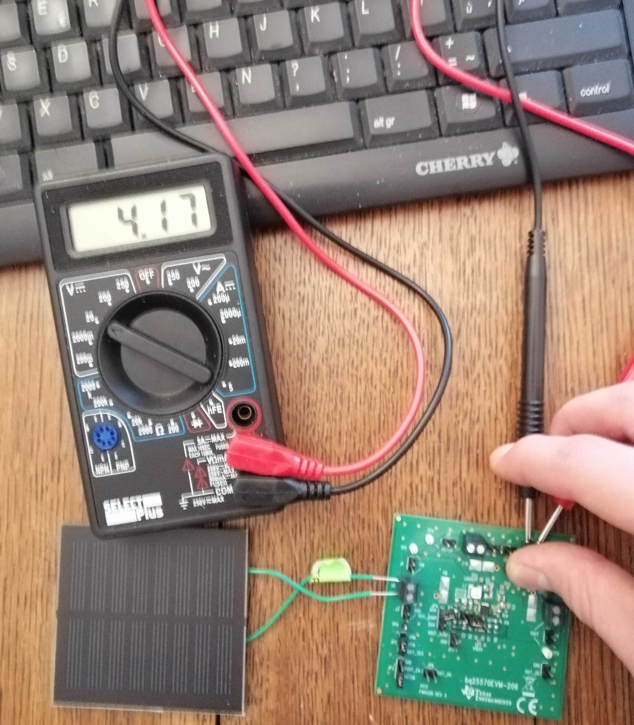

Some useful information I found on Nordic.com:

**Advertising types and whitelisting**

There are 4 defined types of Advertising (Section 2.3.1 Vol 6 Part B):

* **ADV_IND: connectable undirected advertising** . This is the normal advertising type where any device can send scan response packet and connect request to the advertiser.
* **ADV_DIRECT_IND: connectable directed advertising** . You use this to direct your advertise packet to one specific central to ask for connection. The packet is still a broadcast packet but other scanners will ignore the packet if the peer address is not matched with them. And connect request or scan request from unmatched central will be ignored by the advertiser. Directed advertising usually comes with high duty cycle with interval fix at 3.75ms. For low duty cycle directed advertising, it's configurable and should be <10ms. (Section 4.4.2 Part B Vol 6).
* **ADV_SCAN_IND: scannable undirected advertising** . This advertising packet won't accept connect request but accept scan request.
* **ADV_NONCONN_IND: non-connectable undirected advertising** . This is non RX mode, which mean the advertiser will not accept any connect request or scan request. Staying in this mode the advertiser doesn't need to switch to receiver mode and can save power. The main application for this is beacon application, where maximize battery life time is most important and the beacon doesn't need to interact with the scanner.

**Advertise with Whitelist**

The advertiser can use a whitelist to limit the interaction to a number of scanner/central device. The whitelist contains an array of the peer device addresses or IRK numbers (when central use resolvable random address). It will reject packets from scanners/centrals whose addresses are not in the list. Whitelist can be configured to filter scan request packets, connect request packets or both.

Just some info regarding scanning and advertising:

The scanner will scan on one of the advertising channels (37, 38 or 39) for the entire scan interval, and it will change to the next channel in between scan intervals. The advertising devices will advertise on all 3 advertising channels each advertising interval.

An advertisement (on all channels take between 0.5ms and 1ms, depending on your advertising packet size. (see the [online power profiler tool](https://devzone.nordicsemi.com/power/) and enter the payload size to see the timing charts.)

If two devices are advertising at the same time, you will risk that the scanning device only will see jibberish, and ignore both of the advertising packets. So you can do some calculations on what advertising interval you should use on your peripherals.

Regarding the scanning device:

It will scan on one channel for the entire scan window, and it will use some time to change the radio configuration in between the scan intervals. So you would want this interval to not be too long, since that will mean that you will have more time changing channels (and thus not listening). If a packet is not done sending when you change the channel, you will miss that advertising packet.